**Global Vaccine Action Plan**

*Secretariat Annual Report 2016*

*Priority Country report on progress towards*

*GVAP-RVAP goals*

**CHAD**

1. **Progress towards achievement of GVAP goals**
2. **Summary**

This summary table describes the current situation in Chad regarding achieving the GVAP goals. Data used to assess progress towards achievement of GVAP goals are included in the annex.

| **Area** | **Indicator** | **Chad** |
| --- | --- | --- |
| **5. Reach 90% national coverage and 80% in every district with third dose of DTP-containing vaccine** | **National coverage (WUENIC 2015)** | **55%** |
| **Dropout rate DTP1 to DTP3 (2015 WUENIC)** | **8%** |
| **Actual numbers of children who dropped out (2015 WUENIC)** | **28,600** |
| **Difference between poorest and richest quintile DTP3 coverage (2013 data)** | **38.3** |
| **% District coverage reaching 80% coverage from 2015 JRF** | **51%** |

**3.3 Goal 3: Meet vaccination coverage targets**

* 1. **Achieve 90% national coverage and 80% in every district with 3 doses of diphtheria-tetanus-pertussis containing vaccines**

Chad is still quite far from meeting the national and district-level coverage targets for DPT-containing vaccine (pentavalent) and for all other vaccines in the immunization schedule. The 2015 WUENIC estimates show national coverage of 55% for three pentavalent doses, 62% for measles and for three doses of OPV, and 49% for yellow fever. The 2014-2015 DHS/MICS survey shows considerably lower coverage rates, however, with rates for three pentavalent vaccine doses among 12-23 month olds of 33%, 50% for three doses of polio vaccine, and 57% for measles vaccination.[1] High dropout rates – estimated to be 17-26% between DPT1 and DPT3 by several sources – are a major contributing factor for the low coverage rates of both pentavalent and polio vaccines. Administrative data show that 51% of districts in 2015 had achieved DPT3 coverage of ≥80% and these rates are likely to be inflated.[2]

Nonetheless, immunization coverage rates have improved somewhat in the past five years or so, especially for DTP3 and polio 3, with a noticeable jump from 2014 to 2015 (Figure 2). This increase has been mainly attributed to the recent expansion of the RED strategy – to now 54 of the country’s approximately 90 health districts. Efforts to improve coverage among hard-to-reach populations like nomadic herders through intensified vaccination activities may have also played a role. Other factors may include recent improvements in the security situation in the country and the movement of populations from insecure to secure areas, including camps, where they have better access to health care services.

Figure 2: Trends in WUENIC immunization coverage rates in Chad

While there has not been a formal equity assessment, the 2014-15 DHS/MICS showed a 64% increase in pentavalent 3 coverage from the lowest to the highest income quintile (27% vs. 45%), double the coverage rates for children whose mothers had a secondary school education over those with no education (54% vs. 27%) and an eight-point higher coverage rate in urban than rural areas (40% vs. 32%). Coverage is especially low among nomadic and hard-to-reach populations living in remote desert areas.

The main factors contributing to the low immunization coverage rates in Chad include:

* **Insufficient availability of health services, including immunization**

There are not enough health facilities in Chad to make health care services assessable to all. While the government’s plan is to have one health zone (consisting of a health facility) for every 10,000 people – which would require around 1,450 facilities – there are at present around 1,160 functioning health facilities. Health facilities are especially lacking in remote areas with sparse populations. In addition, the 2012 EPI review found that about a quarter of health facilities (24%) do not offer immunization services.[3]

The frequency of immunization services in health facilities that do provide this service is quite favorable compared to several neighboring countries, with 51% of those included in the EPI review reporting that they hold immunization sessions once or twice a week and 39% offering services 5-7 days a week.[4] However, the review also found that 27% of health centers had had to cancel planned immunization services in the prior six months, the main reasons being a lack of personnel, injection supplies and/or kerosene for their refrigerators (or broken down refrigerators). In addition, most vaccinations are provided at fixed sites and the frequency of outreach and mobile activities is inadequate, often as a result of a lack of staff and/or vehicles.[5]

* **Inadequate communications about immunization and weak community involvement in immunization activities**

Chad has a system of health volunteers (*agents de santé communautaire*) in each village, who, among other tasks, promote immunization, inform their communities about upcoming immunization activities and track vaccination defaulters. However, these mobilizers are reportedly not well motivated or involved much in immunization in many areas.[6] There has also been in the past little involvement of civil society organizations (CSOs) in immunization. In addition, the small (three-person) communication team within the central EPI office is over-stretched, has limited resources and focuses mainly on communications in conjunction with the national immunization days and other campaigns. While new vaccine introductions provide the opportunity to increase population awareness about immunization and to therefore increase demand, Chad has not introduced a new vaccine (other than IPV) since 2008. Communications and social mobilization for routine immunization is therefore inadequate. The low literacy rate among women in Chad (32%) creates an additional communications challenge with the public about immunization.

To improve this situation, 22 local associations in 10 districts where the RED approach is being implemented with GAVI support have signed an agreement to promote vaccination in their communities, with assistance from UNICEF. As a result, 1,500 community leaders participated in 2015 in promoting and assisting with immunization activities, 640 community volunteers were recruited and trained to conduct home visits, seek out defaulters and hold social mobilization meetings and other communications activities in their community. Through these efforts, nearly 46,000 children under the age of two were enumerated – the vast majority of whom (86-87%) had not completed their vaccinations and were referred to health facilities to receive missed doses.[7]

* **Insufficient implementation of the Reach Every District (RED) strategy**

With WHO and UNICEF technical support and funding from the Gates Foundation, Chad began implementing the RED strategy in 18 districts in 2004. The program has expanded gradually over time to now 54 of the country’s 90 or so districts, including 22 districts supported through the GAVI HSS grant. Through this support, districts have conducted a series of activities to increase vaccination coverage, including developing and implementing micro-plans, having UNICEF-paid consultants go house-to-house to track defaulters and get them vaccinated, procuring cold chain equipment, increasing the frequency of outreach activities, conducting regular review meetings, and increasing supervisory visits. In 10 of the districts supported by the GAVI HSS grant, 100 new health centers are also being built and equipped with cold chain equipment and motorcycles for outreach activities.

The RED strategy is supposed to be applied nation-wide, but implementation is reportedly weak in the 40% of districts not receiving international assistance for its implementation. Even those that do receive support have had to curtail planned activities due to the slow release of government funds at times. In the GAVI-supported RED districts, activities that did not take place in 2014 due to delays in the disbursement of government funds included the purchase of a refrigerated truck, MLM training for health workers, and supportive supervisory visits.[8] According to one WHO informant, the lack of available budgeted funds at the local level is the first barrier that needs to be overcome to improve the performance of the immunization program.

* **Poor distribution of vaccines and supplies and an inadequate cold chain and logistics system**

Vaccine stockouts at the central level are not a serious problem in Chad, since the Government pays for traditional vaccines and co-financing for yellow fever and pentavalent vaccines in time and in full. However, stockouts of vaccines and related supplies are quite common at the regional, district and health center levels because of a poor vaccine distribution system and inadequate stock management. While a regular vaccine distribution schedule exists on paper (with quarterly deliveries from the central stores to the regions and monthly deliveries from the regions to the health districts), in practice deliveries are erratic and depend on the availability of appropriate transport, which is often lacking.

At the local level, a 2015 cold chain inventory found that while 85% of health centers had refrigerators, only 72% of them were functioning and thus only 62% of health centers could store vaccines.[9] This means that they must collect vaccine from the district stores or from another health center on the day of immunization sessions and are dependent on transportation being available.

* **Weak quality and monitoring of immunization program data**

Administrative coverage data show rates that are 20-40 percentage points higher than the WUENIC estimates; for instance 93% vs. 55% for three pentavalent doses in 2015 and 90% vs. 62% for measles.[10] These high, inaccurate rates can create an unwarranted complacency and prevent the program from taking remedial action in low-performing areas. With partner assistance, district EPI coordinators in the 54 RED districts have been trained on the use of monitoring tools, data harmonization and validation meetings have taken place at the national level, and data review meetings are held at the district level. However, the district meetings are irregular in many places.

* **Geographic inaccessibility and security issues**

Around 4-7% of Chad’s population, including nomadic herders, live in remote areas with poor access to health services. They are also not sufficiently covered by outreach or mobile services, resulting in especially low immunization coverage rates. With support from WHO and other partners, a series of intensified vaccination activities have been carried out in the past several years in seven zones to improve immunization coverage in this population. These are integrated outreach sessions that provide all vaccinations for children under the age of five and TT for pregnant women, as well as distribute malaria medicines and issue birth certificates. An innovative strategy that is used as a further incentive to ensure high participation in these events is to also offer vaccinations for their cattle (e.g., against pasteurellosis and contagious bovine pleuropnemonia).[11]

A lack of security in certain areas, including the Lake Chad region due to Boko Haram terrorists, has also negatively affected immunization coverage rates in the recent past. This situation has recently improved with a four-country security agreement and the removal of residents from insecure areas (e.g., the islands in Lake Chad) to IDP camps and more secure areas.

* **Interruption of routine immunization services during frequent SIAs**

Polio and other SIAs have been frequent in Chad, with and six polio campaigns in 2015 (four national and two local) and many more in the recent past (e.g., 10 or 11 polio campaigns per year in 2010 and 2011). The impact of these frequent events on the delivery of routine immunization services has been raised as a particular issue in Chad in several documents and in interviews with informants.[12] The 2012 EPI review found that 27% of health centers in the study reported that they stopped routine immunization services during the SIAs, mainly because of a lack of health workers and too heavy of a workload. Planning for the campaigns can also interfere with immunization services leading up to the events.

Efforts to address several of these bottlenecks with partner support are discussed in Section B below.

**Annex 1: Country immunization profile**

Figure 4: All vaccines national coverage, Chad, 2000-2015

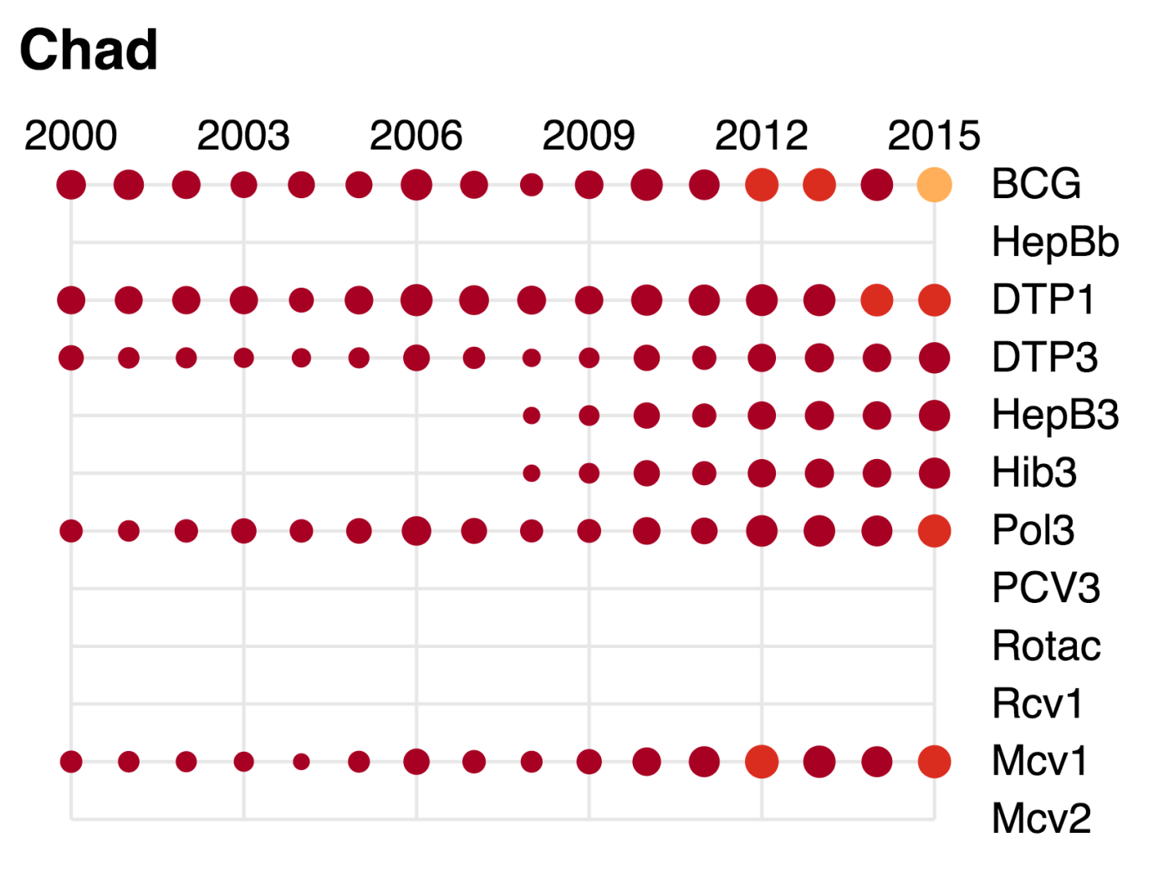

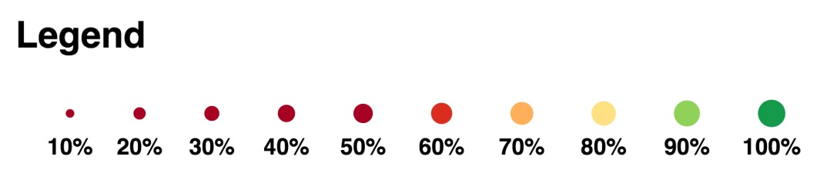

Table 2: Reported DTPCV doses administered & coverage, Chad, 2000-2015

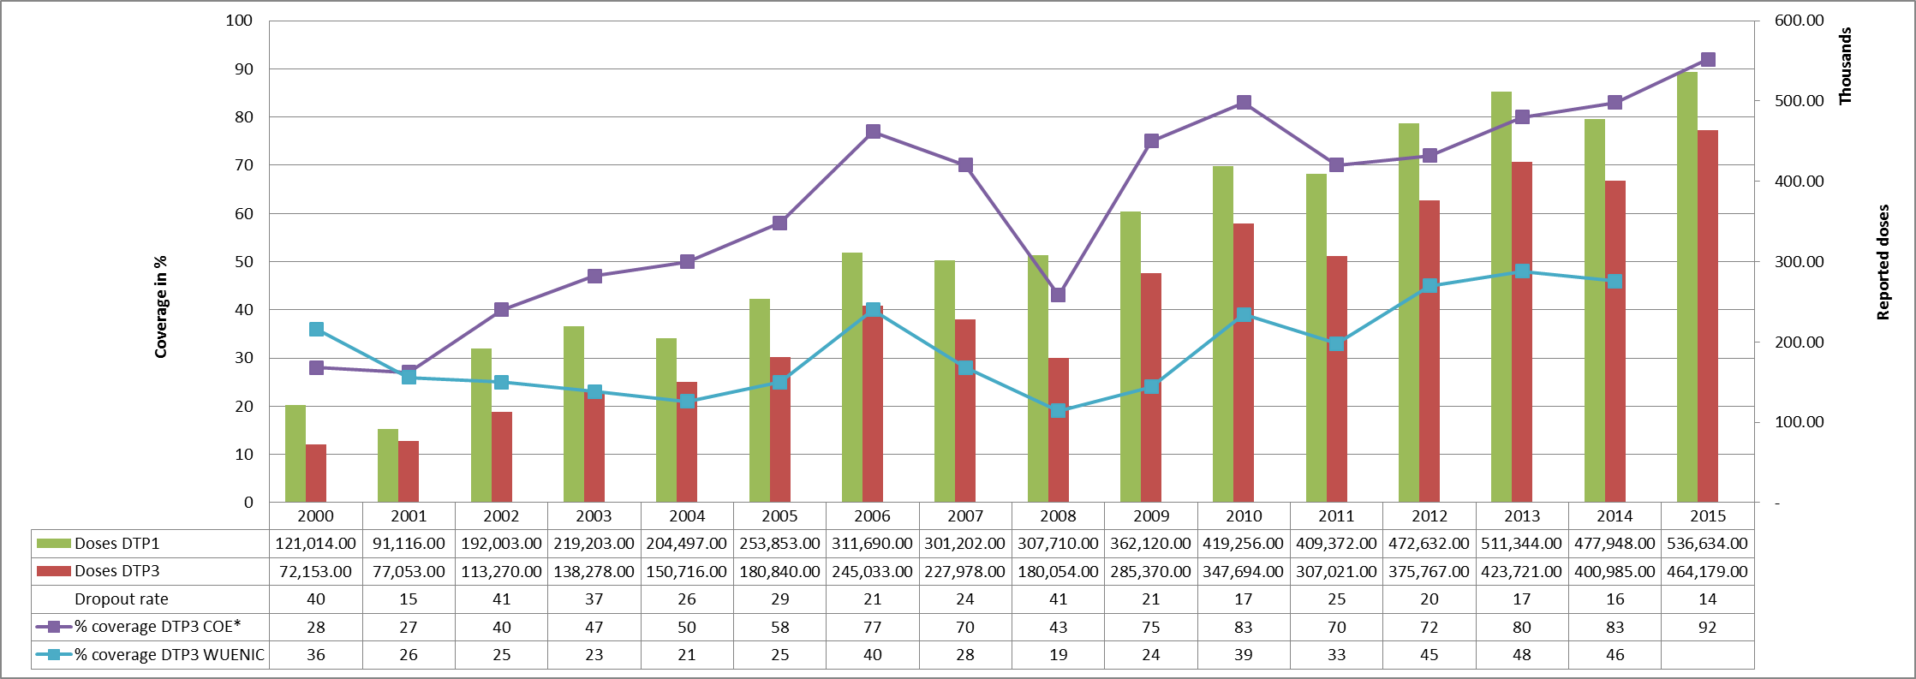

* COE: country Official Estimates

Source:

WHO/IVB database, data reported to WHO by member states as of 1 July 2016

WHO/UNICEF national coverage estimates, 2014 revision, data as of July 2015

Figure 5: Percentage of district achieving <50%; 50-79% and ≥80% coverage, 2000-2015

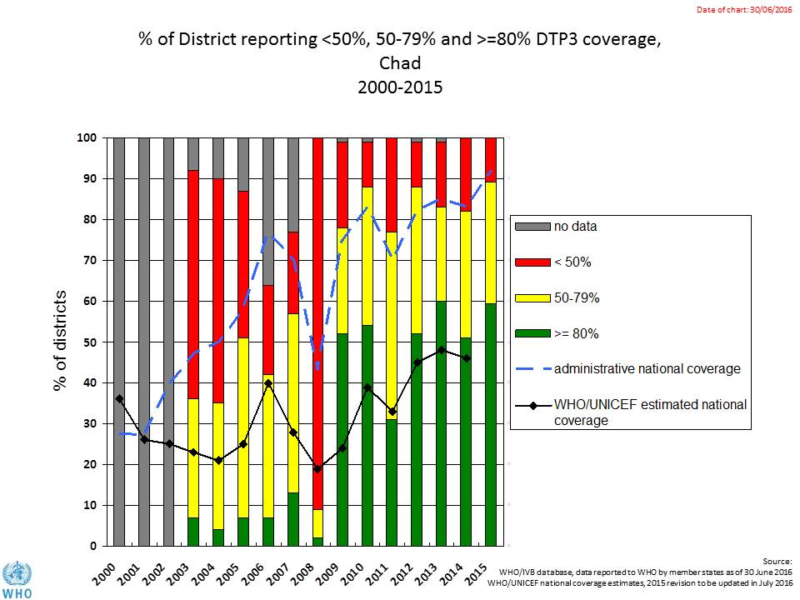

Figure 6: DTP3 coverage by district/province, Chad, 2010 and 2015 (admin)

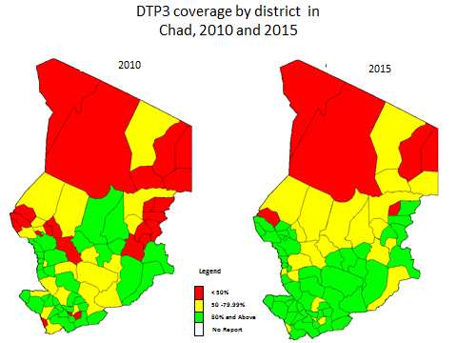

Figure 7: Immunization coverage data disaggregated by sex and wealth quintile

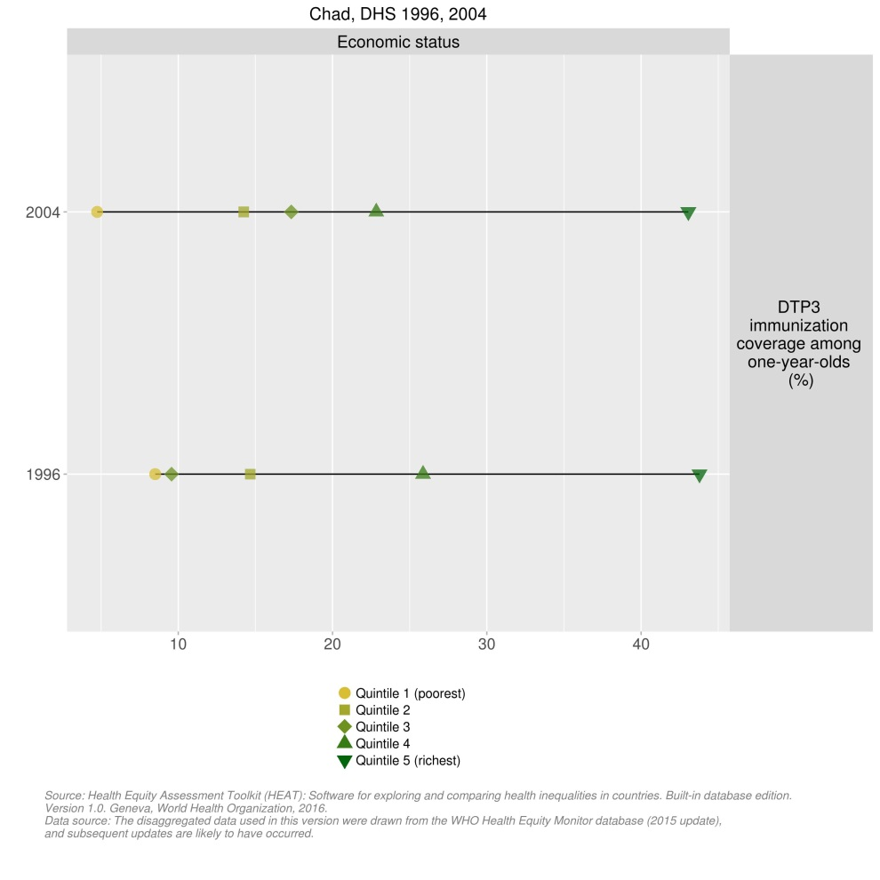

1. Republic of Chad, Demographic and Health Survey (DHS) and Multiple indicator Cluster Survey (MICS), 2015.
2. WHO Immunization country profile (do link).
3. Report of the External Review of the Chad EPI, June 2012
4. Report of the External Review of the Chad EPI, June 2012.
5. Joint Appraisal report 2016.
6. cMYP 2013-2017.
7. Chad Annual EPI Action Plan, 2016
8. Joint appraisal report 2015.
9. Chad EPI Annual Action Plan 2016.
10. Joint appraisal report 2016.
11. Government of Chad and WHO. Report of the third routine vaccination round for nomadic and cross-border populations in the health district of Mani, 7-16 November 2015.
12. EPI review, cMYP.